|  |  |  |  |  |
| --- | --- | --- | --- | --- |
| **National University of Computer and Emerging Sciences, Lahore Campus** | | | | |
| C:\Users\saif\AppData\Local\Microsoft\Windows\Temporary Internet Files\Content.Word\final design.jpg | **Course:** | **Data Base (Lab)** | **Course Code:** | **CS-2005** |
| **Program:** | **BS (Computer Science)** | **Semester:** | **Spring 2023** |
| **Duration:** | **2.5 Hrs** | **Total Marks:** | **55** |
| **Quiz Date:** | **12-June-23** | **Weight** | **_40_** |
| **Section:** | **BCS-4A, BCS-4B, BCS-4C, BCS-4D, BCS-6A [SLOT 2]** | **Page(s):** | **2** |
| **Name** |  | **Roll No.** |  |
|  |  | | | |

**Instruction/Notes:**

1. Use the schema and final exam from the folder: \\cactus1\Xeon\Spring 2023\Zehra Batool\Database Lab Final.
2. Use of internet is not allowed.
3. **Submission Format:**
   1. Make a folder with your Registration No and paste TWO files (Word & SQL) in it.
   2. **Word File:** Queries should be pasted in this given file along with their screenshots of running queries (these are must otherwise marks will be deducted). Submit this word file named as (L13-4632.docx ).
   3. **SQL File:** It includes all your .sql queries of the given questions. (e.g; yourName.sql)
4. Submit your final paper in the given folder. \\cactus1\Xeon\Spring 2023\Zehra Batool\Database Final Submissions\Your Section (e.g; ABC-4K).
5. **Attempt all questions carefully. Your marking is Binary.**

**Use this Scheme (TravelingAgencyDB) for the paper**

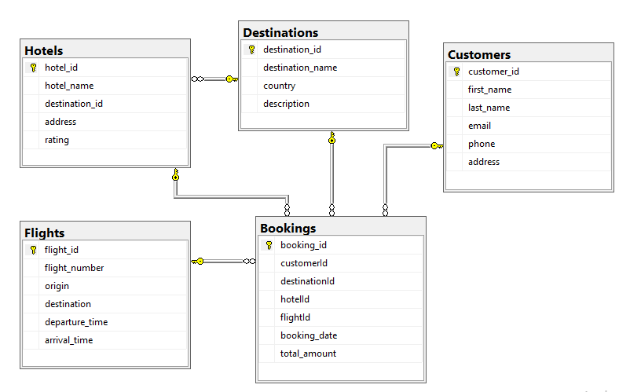

**Question no 1:**  **[5 (1.5 SS) + 5 (1.5 SS)= 10 Marks]**

1. Write a SQL query to retrieve the booking details (booking ID, customer ID, total amount) for customers who have booked a hotel in **Paris**. (Nested Query)
2. Write a SQL query which retrieves the destination name along with the count of customers who have made bookings for the same destination more than once.

**Question no 2: [7.5 (1.5 SS) + 7.5 (1.5 SS)= 15 Marks]**

1. Create a view named "CustomerBookings" that displays the customer's full name, email address, booking date, destination name, hotel name, and flight number for each booking made by the customers. Include only the bookings where the destination country is 'United States'.
2. Create a view that have a query to retrieve the top 5 customers who have made the most bookings in the past month. Include the customer name, email address, and the total number of bookings for each customer. Display the results in descending order (total number of bookings).

**Question no 3: [7.5 (1.5 SS) + 7.5 (1.5 SS)= 15 Marks]**

1. Create a stored procedure GetCustomerBookings takes a parameter @customerId and retrieves the bookings made by a specific customer. The result should be the booking ID, customer name, destination name, hotel name, flight number, booking date, and total amount.
2. Create a procedure GetBookingDetails which takes a parameter @bookingId and retrieves the details of a specific booking. The result should include the booking ID, customer name, destination name, hotel name, flight number, booking date, and total amount.

**Question no 4: [7.5 (1.5 SS) + 7.5 (1.5 SS)= 15 Marks]**

1. Ali wants to track the changes made to the email addresses of customers in the Customers table. How Ali can use triggers to log these changes into an audit table?
2. Ali wants to maintain a log of all flight departures in a separate table whenever a flight departs. How Ali can use triggers to accomplish this?

********************************